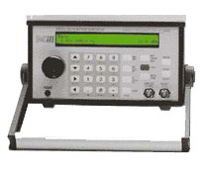
Arbitrary Waveform Program for the
Berkeley Nucleonics™ Model 625/625A
Copyright © Richard L. Grier 2010
Hard & Software www.hardandsoftware.net
I purchased a Telulex™ SG-100 Arbitrary Waveform Generator about 12 years ago. Telulex was acquired by Berkeley Nucleonics a few years later, and the product was re-modeled the Model 625 see: http://www.berkeleynucleonics.com/products/model-625.html). My original plan was to use this “arb” on my bench as a replacement for a manual HP function generator, and to write a program or two to add to the collection in my book, Visual Basic Programmer’s Guide to Serial Communications (1-4), to illustrate the generator’s RS-232 port for programming and control.
I used the BN625 as a desktop instrument, and wrote some simple programs to control it, but these were too crude to be very good additions to my book, so I didn’t include the programs with it. One of the problems with the BN625 is that the instrument, though quite powerful for its day, didn’t include any software to implement the arbitrary waveform functions, beyond a simple DOS program, and the programming examples were crude. Also, these programs didn’t address the issue of creating a graphical user interface for either control or waveform creation or editing. An arbitrary waveform generator without such software is rather limited.
As I approached the start of a new project that would require use of such waveform generation capability, I had to make a move. Should I purchase a new waveform generator that comes with the requisite software? These range from a $300 and up, and some of the lower priced versions (which are quite capable) actually rely on “free” 3rd party software for waveform creation and editing. A popular example of this free software is ArbExpress ™ from Tektronix Corporation (see: http://www.tek.com/products/signal_sources/arbexpress.html). This software is a free download, and all that is required is that you agree to the License that I’ll quote here:
Not all free software has gone through Tektronix normal quality control or production processes, but is provided to users as an accommodation to respond to user requests. The free software is provided hereunder on an As-Is basis without any representation or warranty. Tektronix disclaims all warranties, whether express or implied, including warranties of merchantability, fitness for a particular purpose and non-infringement of intellectual property rights. In no event shall Tektronix be liable for any direct, indirect, special, incidental or consequential damages in any way arising out of or connected with the use of the free software.
Fortunately, Tektronix does not limit the use of ArbExpress to use with their own hardware. So, the notion occurred to me… Why not see if I could use ArbExpress with my BN625 Arbitrary Waveform Generator? It turns out that this is both practical and useful. I am grateful that Tektronix has made this software available.
I decided to use Microsoft Corporation ™ Visual Basic (VB 2008) for this project. The free Express Edition would work fine, though I employed Visual Studio 2008 Professional.
Here is what ArbExpress looks like in operation:
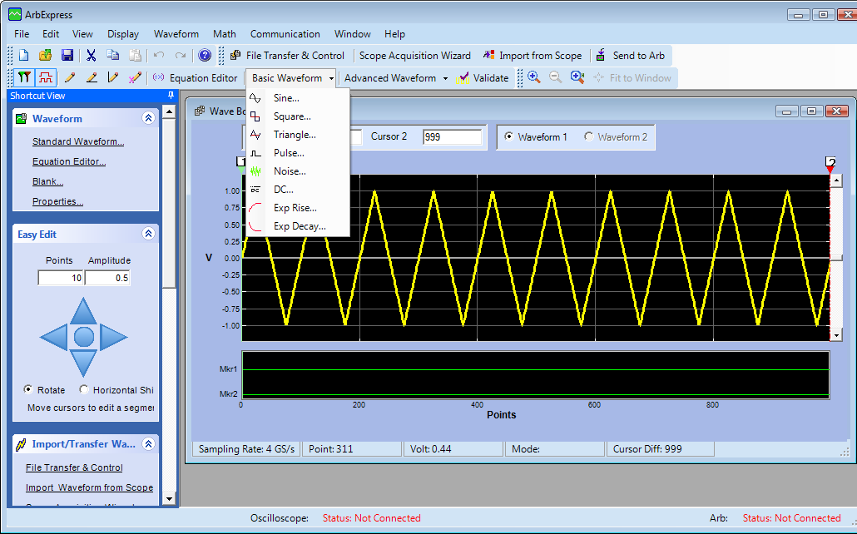
This run used the “Standard Waveform” mode to create a triangle waveform from the Basic Waveform menu. Here is the “Advanced Waveform” menu with Sinc selected:
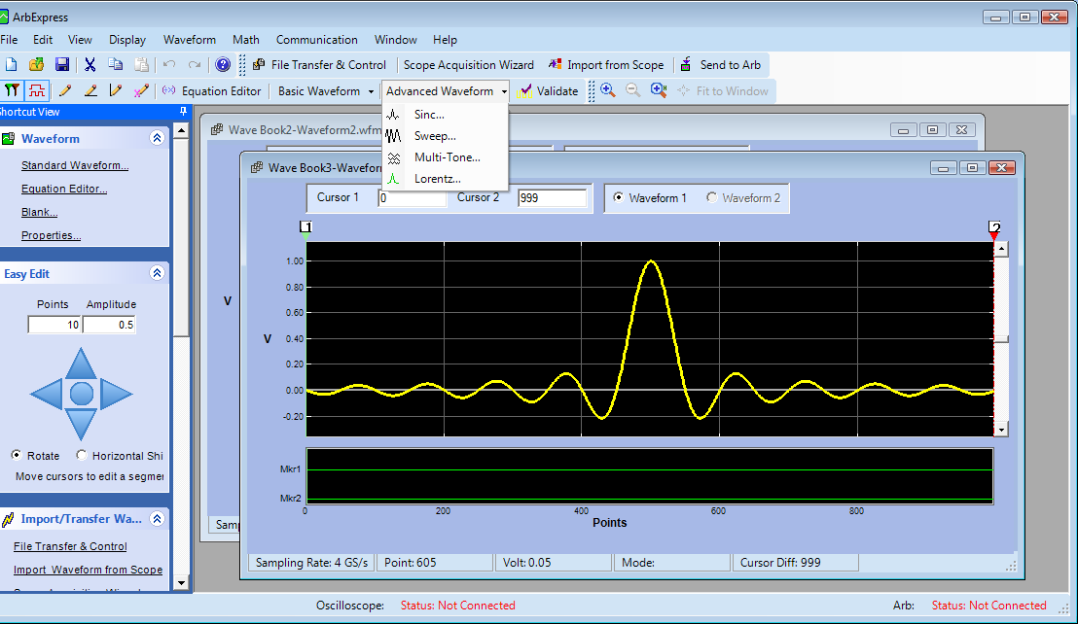
You may use the Equation Editor to create a waveform from a mathematical expression (not illustrated here), or Blank to draw a waveform on screen, that many not be easily described mathematically. For example:
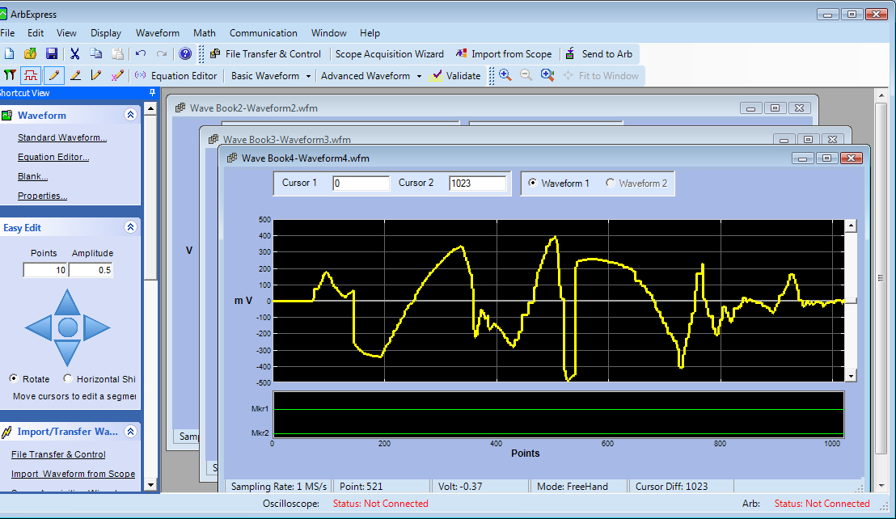
This was drawn “freehand” and might represent the data acquired from a pressure or other transducer.
Once you have used ArbExpress to create (or, later, edit) a waveform, you need to save it using a file format that will make it easy to upload to the waveform generator. The BN625 accepts a simple CSV point value format, and the ArbExpress “Save As” menu allows you to select a CSV file. Naturally, you should use a filename that makes this file easy to recall later, though our VB program will upload the file automatically to the waveform generator, if so configured. More about this feature later.
There is one more important point that should be considered. ArbExpress allows you to add “markers” that might be used to trigger an oscilloscope or to provide a sync output from the waveform generator, for some other purpose. The BN625 has a single sync output that may be used, so I’ve added code that uses any 1 added to Mkr1 to activate the sync output coincident with this sample. Mkr2 is not used, and any changes made there will be ignored. Here is a screen shot (freehand mode was used to add this point to Mkr1):
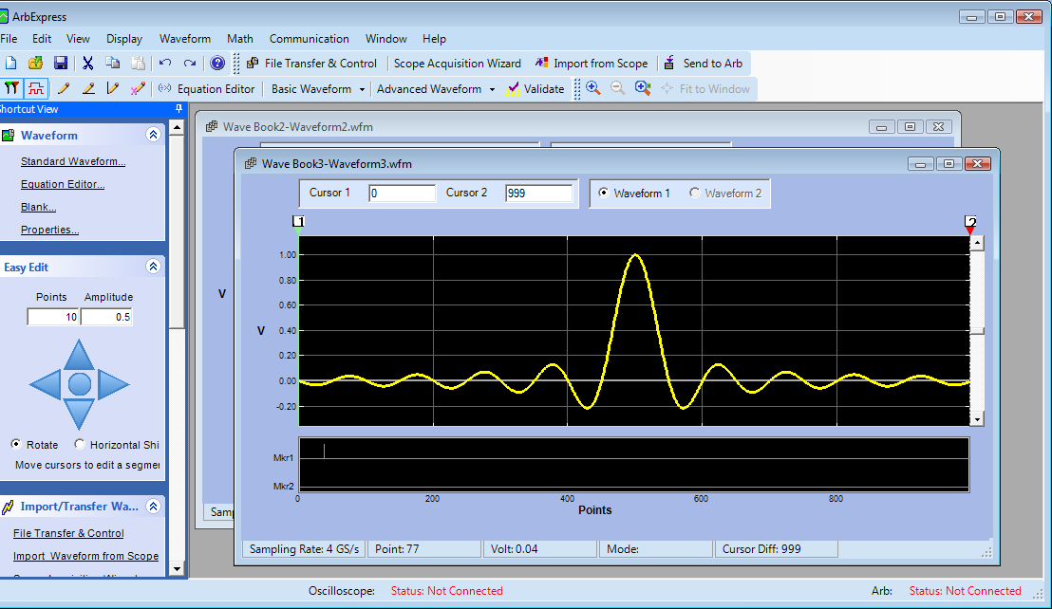
Now that we have a feel for ArbExpress, how do we actually use it in a useful way?
Here are the things that will be in the Windows Client VB program:
- An interface that allows us to activate ArbExpress to create waveforms.
- The ability to detect when ArbExpress has created or edited and then saved a waveform and to automatically upload that waveform to the BN625 arbitrary waveform generator, if so configured.
- Upload previously saved waveforms.
- Automatically detect a connected and powered up BN625 Arbitrary Waveform Generator, if so configured.
- Configure and set the sampling rate to be used by the generator that sets the basic repetition rate of the arbitrary waveform.
These are fairly basic requirements, but the result is a fully usable control program that improves the utility of the BN625 significantly.
Here are screen shots, with some operational details.
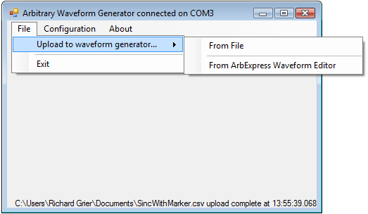
This is the UI. The program was configured to automatically detect a connected BN625. The waveform generator was located on COM3. The use has selected from the File/Upload to waveform generator menu, and may now select either From File (next screen shot), or From ArbExpress Waveform Editor, shown earlier. A previously generated waveform had been uploaded to the BN625 at 13:55:39.
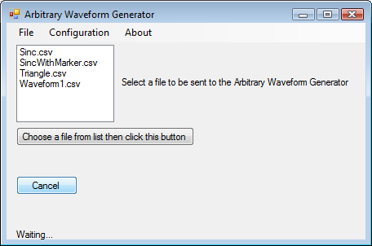
When you select the configuration menu, the following screen is presented.
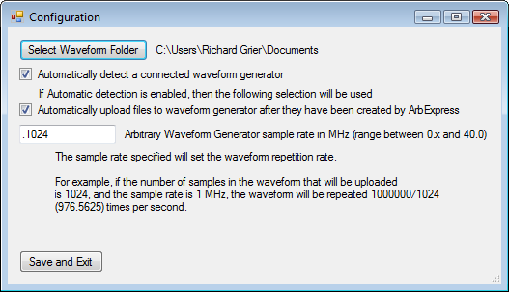
The only parameter that might cause question is that of the Arbitrary Waveform Generator sample rate. The value entered here should range from 0+ to 40 MHz, and must be a numeric value. Choose this value to set the waveform repetition rate. If you use a sample rate that is a multiple of the number of samples in the waveform, the repetition rate will be integral and easy to view. Naturally, the actual sample rate need not result in an integral repetition rate. Also, the sample rate may be adjusted from the waveform generator front panel.
The following screenshot shows the output of the BN625 Arbitrary Waveform Generator as captured by a PicoScope 3224 (see: www.picotech.com for details). Note this waveform is from the file SincWithMarker.csv and thee configuration parameters set in the preceding screen were used.
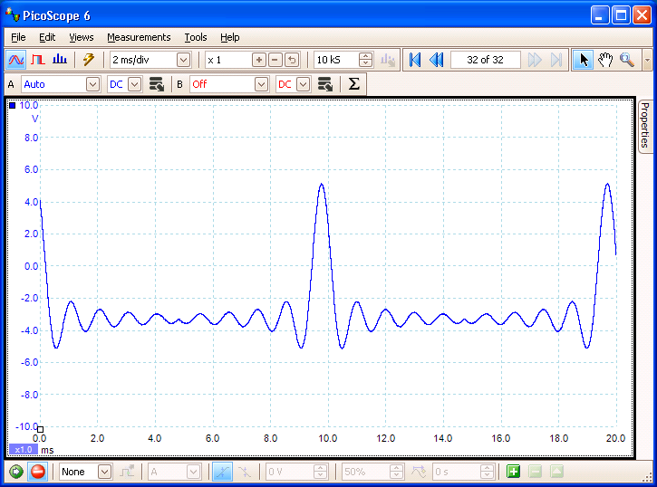
All of the source code for this project is provided in my book, Visual Basic Programmer’s Guide to Serial Communications 4. See Books on my homepage www.hardandsoftware.net. You also may contact me directly for more information.

